EMPLOYEE MANAGEMENT SYSTEM

1.

QUERY

SELECT EmployeeID, SUM(SalaryAmount) AS TotalSalary FROM Salary GROUP BY EmployeeID;

OUTPUT:

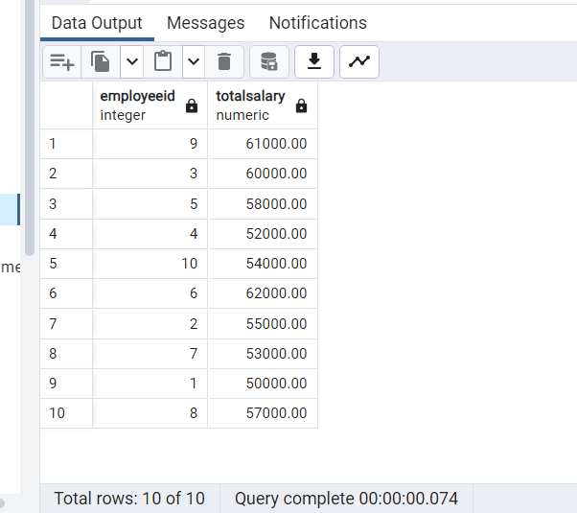

2.

QUERY:

SELECT DepartmentName, COUNT(*) AS EmployeeCount FROM Employee

JOIN Department ON Employee.DepartmentID = Department.DepartmentID

GROUP BY DepartmentName;

OUTPUT:

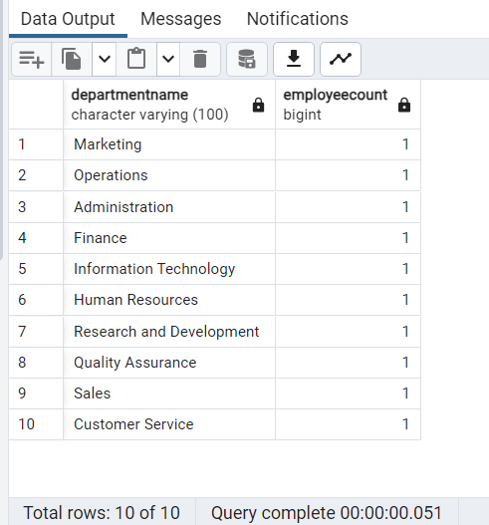

3.

QUERY

SELECT * from Employee where DepartmentID=1;

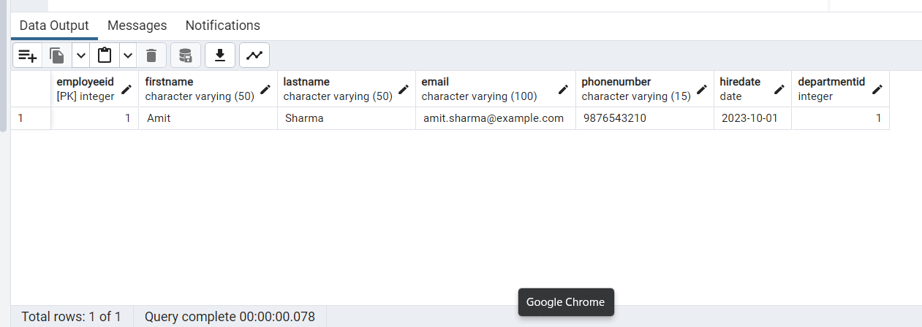

4.

QUERY:

DO $$

BEGIN

-- Declare variables

DECLARE

employee_count INT;

department_name VARCHAR(100);

-- Initialize variables

employee_count := 0;

department_name := '';

-- Get the count of employees in a specific department

SELECT COUNT(*) INTO employee_count FROM Employee WHERE DepartmentID = 1;

-- Get the name of the department

SELECT DepartmentName INTO department_name FROM Department WHERE DepartmentID = 1;

-- Display the result

RAISE NOTICE 'Department % has % employees.', department_name, employee_count;

END $$;

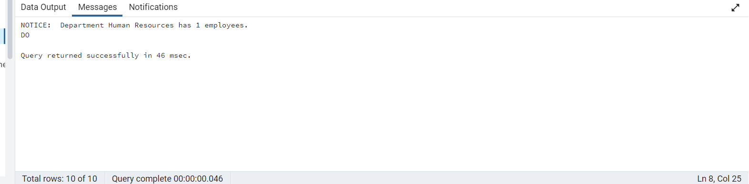

5.

QUERY

CREATE OR REPLACE FUNCTION insert_employee(first_name VARCHAR, last_name VARCHAR, email VARCHAR, hire_date DATE, department_id INT)

RETURNS VOID AS $$

BEGIN

INSERT INTO Employee (FirstName, LastName, Email, HireDate, DepartmentID)

VALUES (first_name, last_name, email, hire_date, department_id);

END;

$$ LANGUAGE plpgsql;

SELECT * FROM Employee where EmployeeID=11;

OUTPUT :

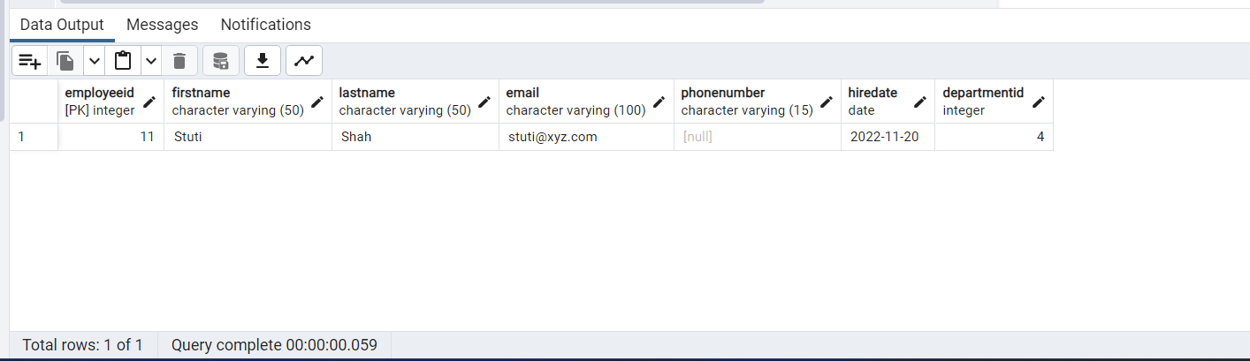

6.

QUERY

CREATE OR REPLACE PROCEDURE update_salary(

IN employee_id INT,

IN new_salary DOUBLE

)

LANGUAGE plpgsql

AS $$

BEGIN

UPDATE Salary SET SalaryAmount = new_salary WHERE EmployeeID = employee_id;

END;

$$;

OUTPUT :

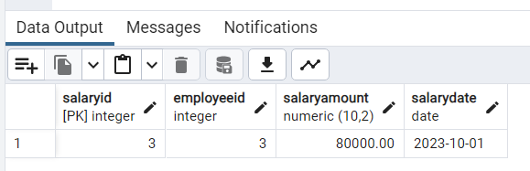

7.

QUERY

DO

$$

DECLARE

display_details CURSOR FOR SELECT FirstName,LastName,HireDate FROM Employee WHERE EmployeeID=9;

f_name Employee.FirstName%type;

l_name Employee.LastName%type;

h_date Employee.HireDate%type;

BEGIN

OPEN display_details;

LOOP

FETCH display_details INTO f_name,l_name,h_date;

EXIT WHEN NOT FOUND;

RAISE NOTICE 'First name : % , Last name : % , Hire Date : %',f_name,l_name,h_date;

END LOOP;

CLOSE display_details;

END;

$$

OUTPUT :

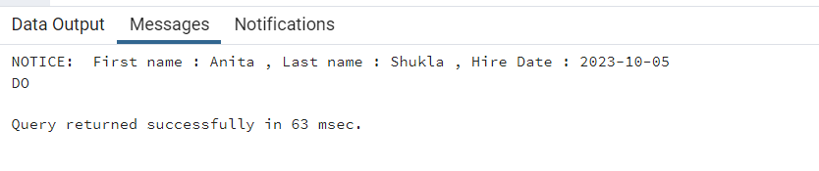

8.

QUERY

SELECT Employee.FirstName, Employee.LastName, Employee.Email, Department.DepartmentName

FROM Employee

INNER JOIN Department ON Employee.DepartmentID = Department.DepartmentID;

OUTPUT :

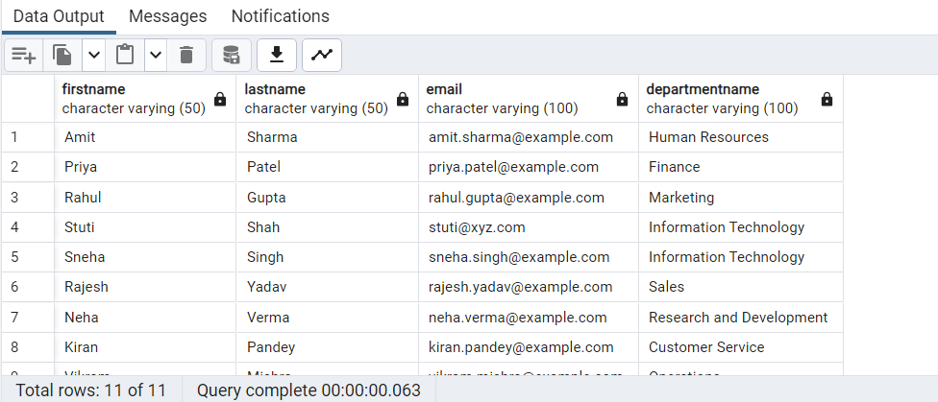

9.

QUERY

CREATE VIEW ApprovedLeaveRequests AS

SELECT LeaveRequest.*, Employee.FirstName, Employee.LastName

FROM LeaveRequest

JOIN Employee ON LeaveRequest.EmployeeID = Employee.EmployeeID

WHERE LeaveRequest.Status = 'Approved';

OUTPUT :

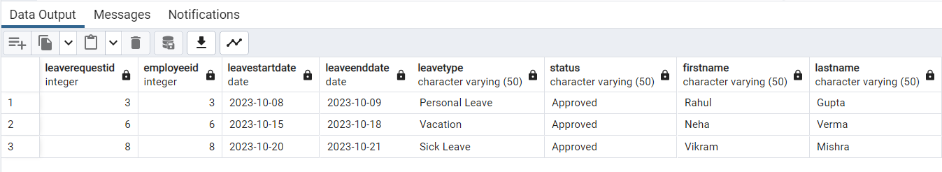

10.

QUERY

SELECT * FROM Employee WHERE EmployeeID IN (SELECT EmployeeID FROM LeaveRequest WHERE Status = 'Pending');

OUTPUT :

